# Dymo Printer Driver testing instruction.

The driver installation is “Lw5xxDrv.exe”.

* Use LW550Util to send ZPL file to the spooler/driver after installation of driver.
* Please open the command prompt from the folder which contains “LW550Util.exe”.
* Please run Command: LW550Util.exe -ps [ZPL file path]

Execute the GUI tool to configure ZPL parameters and debug information.

The executable file is located in "LW5xx_1.1.0.214\LW5xxOptions\Lw5xxOpts.exe".

When you click "OK" after configuration, the spooler will restart to read the configuration.

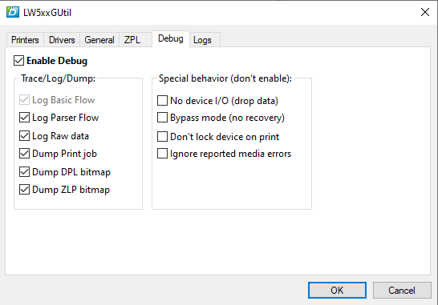

**To remove the driver**, Please click on the "Delete Drivers" button under the Driver tab and disconnect the printer before executing the delete function.

